1. Youth will go into their portal, enter their time, and save. On the timecard due day, the intern will click “Save & Submit Timesheet” if there are hours to submit for that week. Alternately, if there are no hours, they will click “Submit Zero Hours.”

1. After the intern submits their timecard from their portal, BOTH the direct supervisor and

youth employment counselor will receive this “APPROVE OR REJECT” email:

.

1. **DO NOT CLICK THE APPROVE TIMESHEET BUTTON** within the email. The immediate supervisor received the same “APPROVE OR REJECT” email above – the immediate supervisor should be the one to click the “Approve Timesheet” blue button for the documented approval.
2. Login to your Avionte portal to view timecards. You can view all interns that you manage.

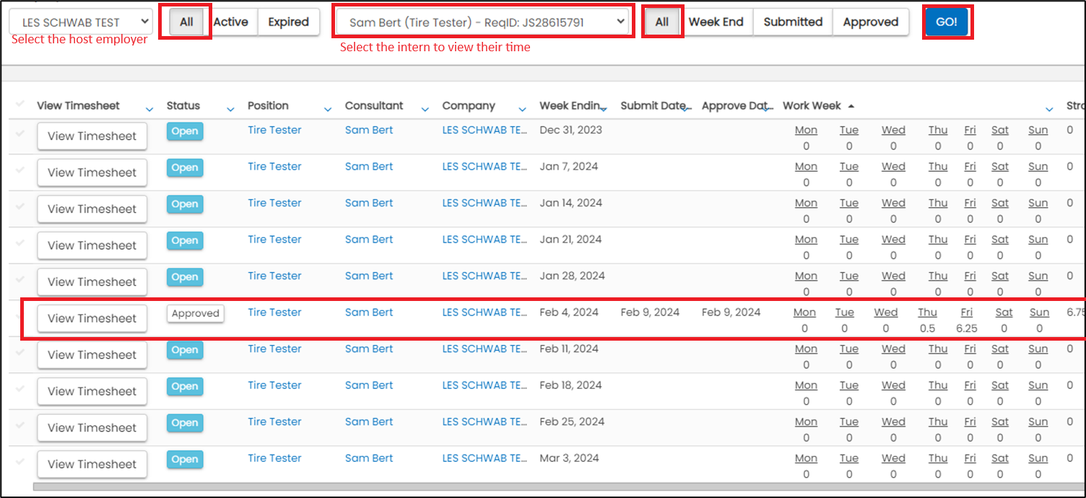

* You can view the timesheets, see when they were submitted by the intern and when the “Approve Timecard” button was clicked by the supervisor.

*\* Mid Oregon Personnel will only pay timecard submissions that were approved by clicking the “Approve Timecard” button or a request in writing from COIC/YCC to process. If a supervisor is unable to approve, COIC/YCC can review the “APPROVE OR REJECT” email and click “Approve.”*